Sam Tenney

Section 2

Homework 7

1. Perfect Cookies
2. Response Variable: Cookie diameter in inches.

Factors: Temperature of oven (370, 375, 380, 385oF), Fat ingredient (butter, margarine).

Treatments: There are eight treatment combinations of the factors and factor levels. They are as follows: 370oF-Butter, 370oF-Margarine, 375oF-Butter, 375oF-Margarine, 380oF-Butter, 380oF-Margarine, 385oF-Butter, 385oF-Margarine

1. set.seed(1995)  
   sample(1:24, replace=FALSE

## [1] 21 19 9 5 12 14 20 11 16 8 6 7 23 2 24 15 4 1 18 22 17 3 13  
## [24] 10

Design Table

|  |  |  |  |
| --- | --- | --- | --- |
| Experiment | Factor 1 Level: Temperature | Factor 2 Level: Ingredient | Replicate |
| 1 | 370 | Butter | 1 |
| 2 | 370 | Butter | 2 |
| 3 | 370 | Butter | 3 |
| 4 | 370 | Margarine | 1 |
| 5 | 370 | Margarine | 2 |
| 6 | 370 | Margarine | 3 |
| 7 | 375 | Butter | 1 |
| 8 | 375 | Butter | 2 |
| 9 | 375 | Butter | 3 |
| 10 | 375 | Margarine | 1 |
| 11 | 375 | Margarine | 2 |
| 12 | 375 | Margarine | 3 |
| 13 | 380 | Butter | 1 |
| 14 | 380 | Butter | 2 |
| 15 | 380 | Butter | 3 |
| 16 | 380 | Margarine | 1 |
| 17 | 380 | Margarine | 2 |
| 18 | 380 | Margarine | 3 |
| 19 | 385 | Butter | 1 |
| 20 | 385 | Butter | 2 |
| 21 | 385 | Butter | 3 |
| 22 | 385 | Margarine | 1 |
| 23 | 385 | Margarine | 2 |
| 24 | 385 | Margarine | 3 |

Check Sheet

|  |  |  |  |
| --- | --- | --- | --- |
| Run | Experiment | Factor 1 Level: Temperature | Factor 2 Level: Ingredient |
| 1 | 21 | 385 | Butter |
| 2 | 19 | 385 | Butter |
| 3 | 9 | 375 | Butter |
| 4 | 5 | 370 | Margarine |
| 5 | 12 | 375 | Margarine |
| 6 | 14 | 380 | Butter |
| 7 | 20 | 385 | Butter |
| 8 | 11 | 375 | Margarine |
| 9 | 16 | 380 | Margarine |
| 10 | 8 | 375 | Butter |
| 11 | 6 | 370 | Margarine |
| 12 | 7 | 375 | Butter |
| 13 | 23 | 385 | Margarine |
| 14 | 2 | 370 | Butter |
| 15 | 24 | 385 | Margarine |
| 16 | 15 | 380 | Butter |
| 17 | 4 | 370 | Margarine |
| 18 | 1 | 370 | Butter |
| 19 | 18 | 380 | Margarine |
| 20 | 22 | 385 | Margarine |
| 21 | 17 | 380 | Margarine |
| 22 | 3 | 370 | Butter |
| 23 | 13 | 380 | Butter |
| 24 | 10 | 375 | Margarine |

1. That would be faster, but it wouldn’t be a randomized basic factorial design since we are choosing the order we apply the temperature treatment.
2. That would be more expensive, and the ovens could perform differently from one another. To limit our confounding variables, it’s best we use the same oven so the trials receive consistent treatments throughout the experiment.
3. Perhaps the wait time to be put in the oven will have different effects on the cookie diameter that we wouldn’t be able to account for. It’s best to keep it consistent throughout the experiment.
4. The model is yijk = µ + αi + βj + γij + ɛij. The variable yijk is the cookie diameter in inches for the kth replicate of the ith temperature (in Fahrenheit; 370, 375, 380, 385) and the jth  fat ingredient level (butter, margarine). The variable µ is the grand mean of all the cookie diameters (inches). The variable αi is the treatment effect for the ith temperature (Fahrenheit) level. βj is the treatment effect for the jth fat ingredient level. γij is the interaction effect for the ith temperature level and the jth fat ingredient level. The error for the kth replicate with ith temperature (Fahrenheit) and the jth fat ingredient is represented by ɛijk .
5. Ho: γ11 = γ12 = … = γIJ = 0

Ha: at least one γIJ ≠0

1. H­o: α1 = α2 = … = αi = 0

Ha: at least one αi ≠0

1. Ho: β1 = β2 = … = βj = 0

Ha: at least one βj ≠ 0

1. Receipt Personalization and Tipping Behavior
2. Graph 1

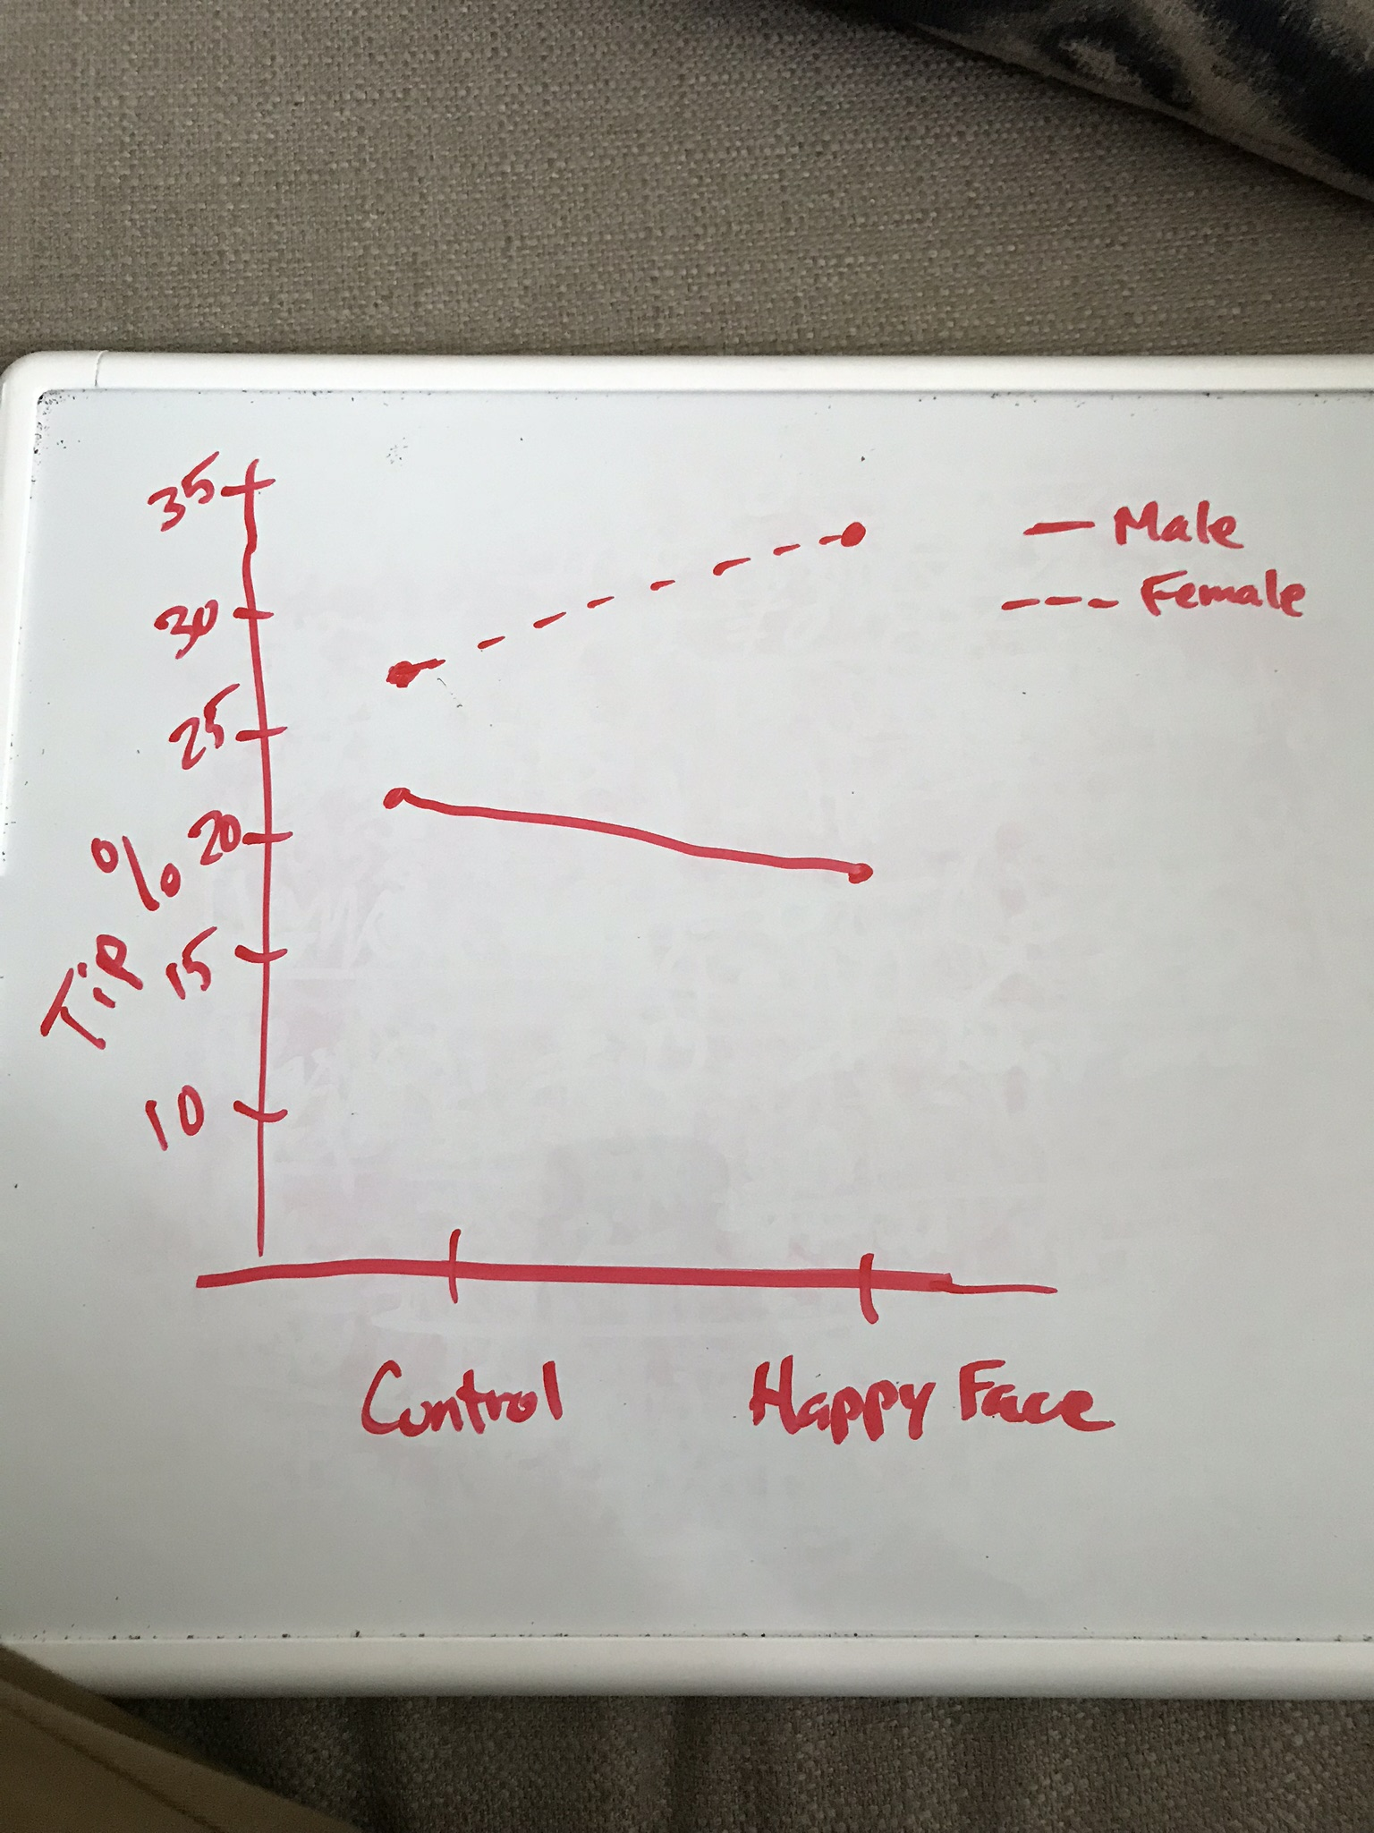

Graph 2

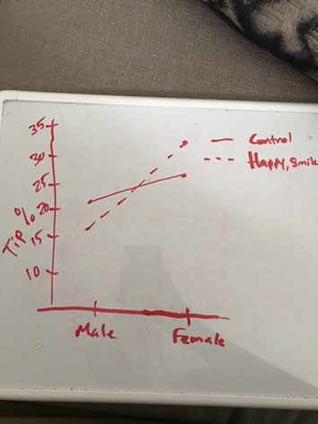

I prefer Graph 1 because it’s easy to see that both the gender and tipping delivery have an interaction in what the tipping percentage is.

1. When gender is held constant at male, changing the tipping delivery from the blank check to the happy, smiling face causes a slight decrease in the tipping percentage.

Meanwhile, when gender is held constant at female, changing the tipping delivery from blank check to the happy, smiling face causes a slight increase in the tipping percentage.